Fossil trees of the late Eocene Florissant valley

Answer Key
Fagopsis (extinct genus in the Beech Family)
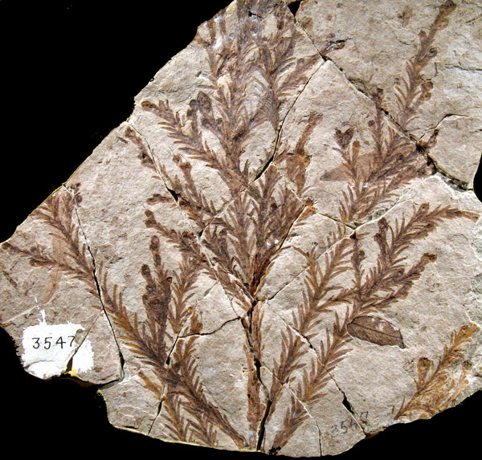
Redwood (Genus: Sequoia)
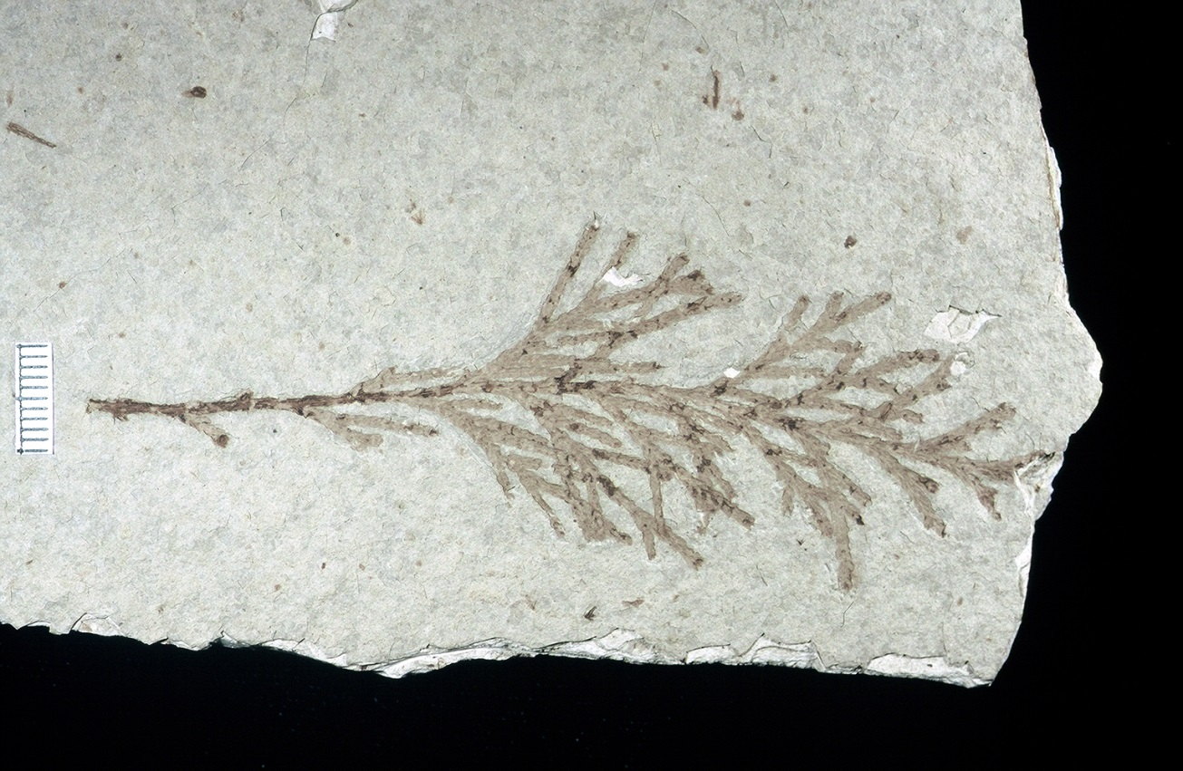
White Cedar (Genus: Chamaecyparis)
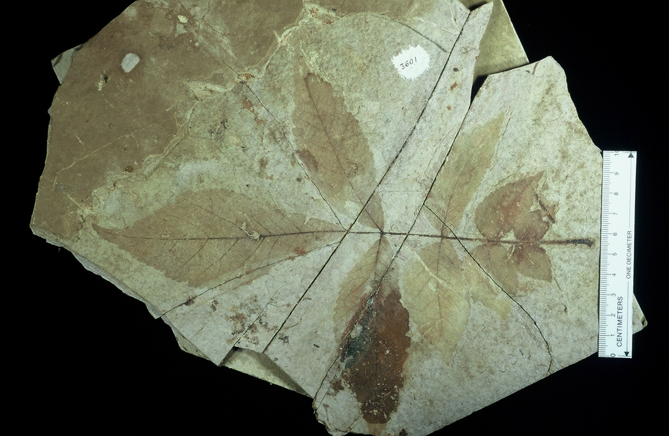Hickory (Genus: Carya)
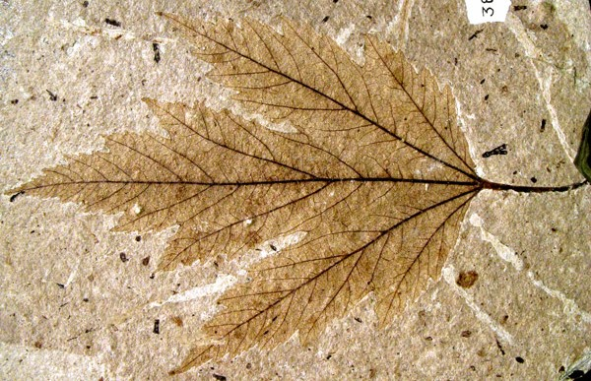
Maple (Genus: Acer)
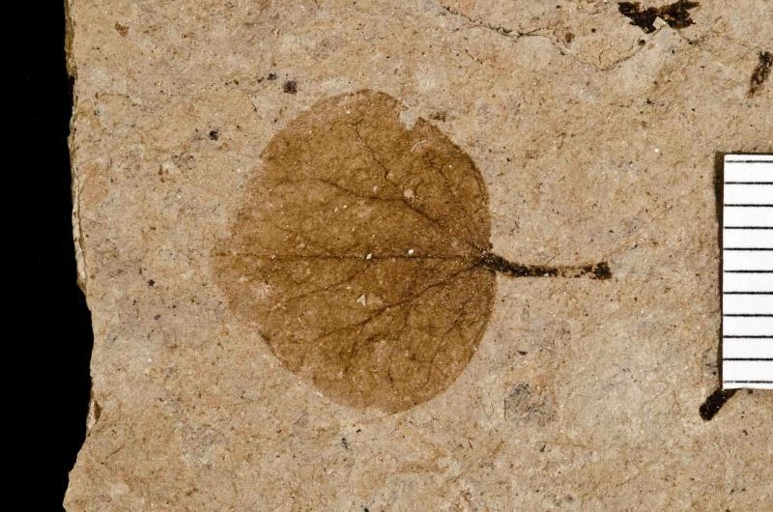Redbud (Genus: Cercis)
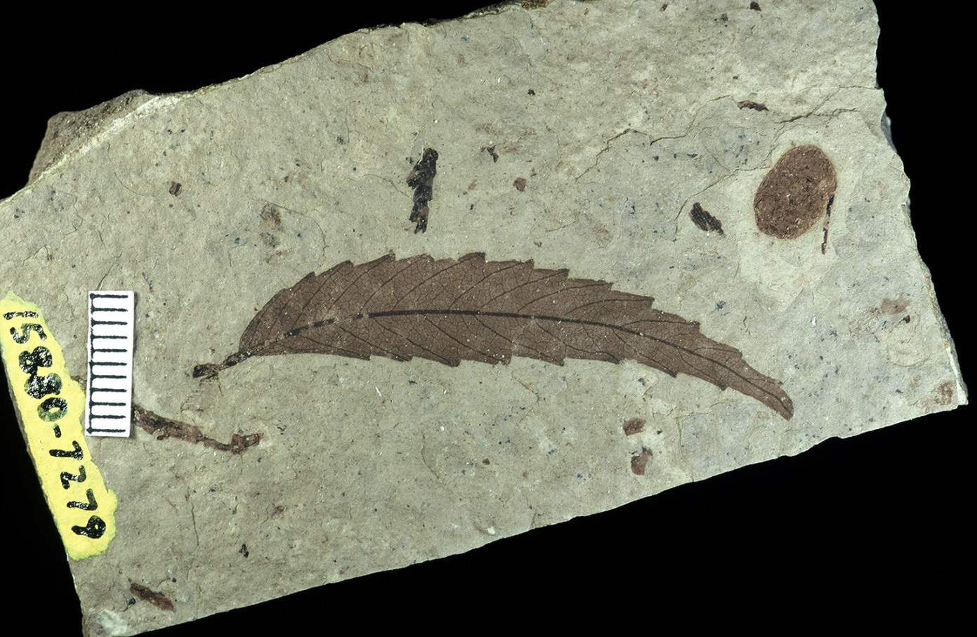
Elm (Genus: Ulmus)
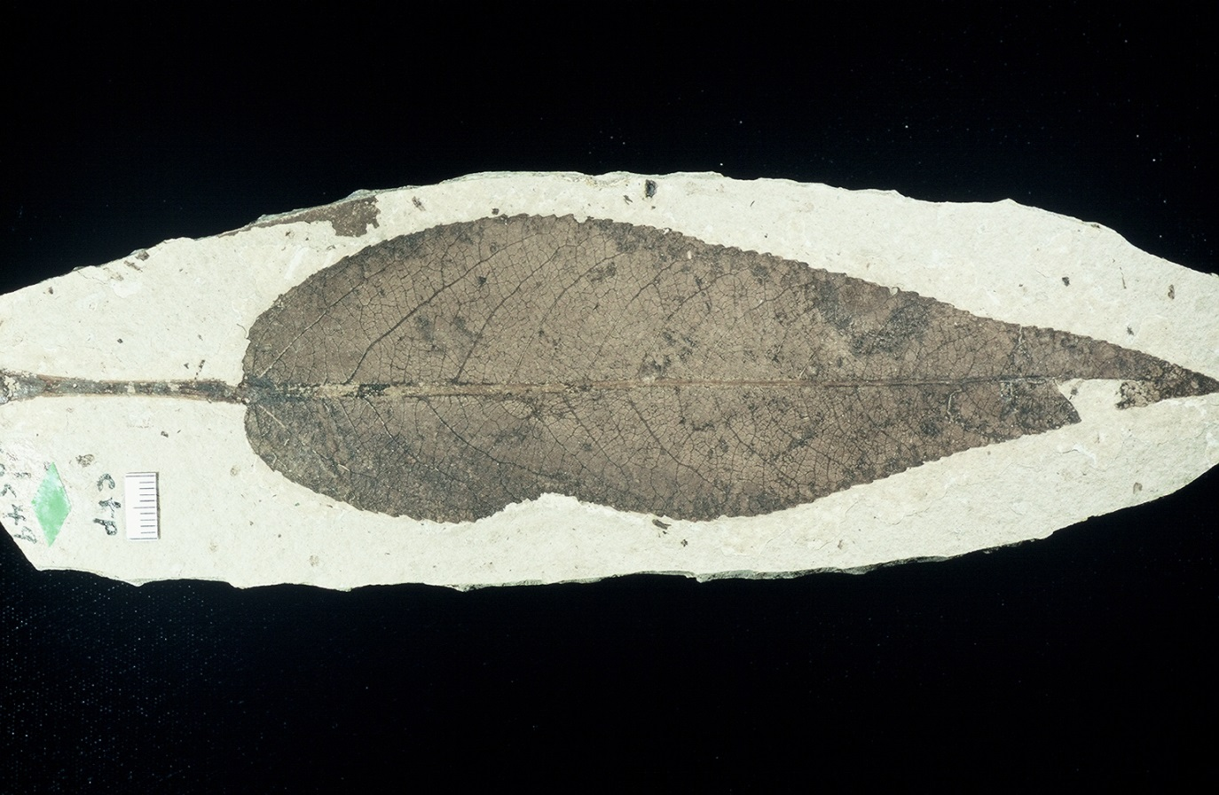Poplar (Genus: Populus)
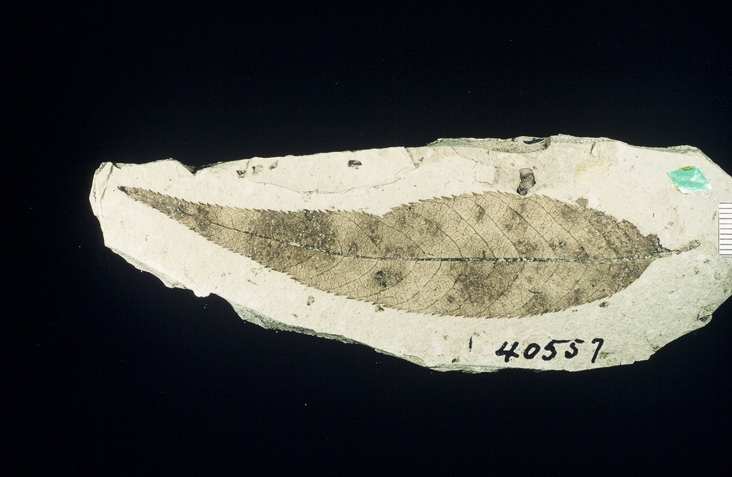
Willow (Genus: Salix)

